Midreview-1 Program

# Author = Darren Isaacson

# This program is designed to calculate the total cost of meal.

print("Thank you for dining with us today \n------------------------------------")

# Global tax varible

tax = 1.075

# Input of Food

costofMeal = float(input("What was the cost of your meal?\n$"))

# Input validation for food cost

if costofMeal <= 0:

costofMeal = 0

else:

costofMeal = costofMeal

# Input for Tip

getTip = float(input("Would you like to leave a tip? Enter in a tip value if so:"))

# Validation for tip

if getTip <= 0:

getTip = 0

else:

getTip = getTip

# Calculations

taxTotal = costofMeal * tax

fullTotal = taxTotal + getTip

# Output

print("------------------------------------")

print("Food: $%.2f" % taxTotal)

print("Tip: $%.2f" % getTip)

print("Total = $%.2f" % fullTotal

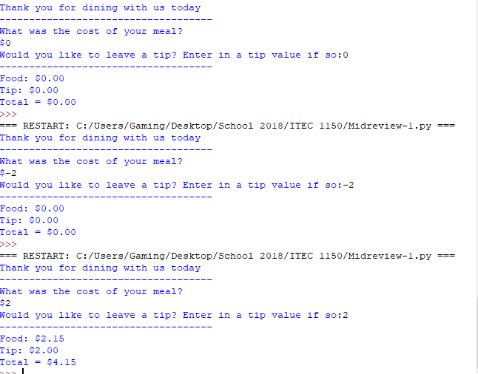

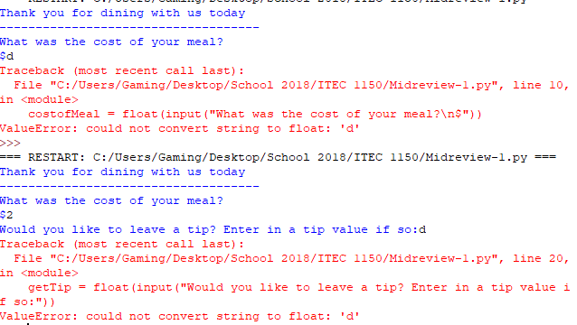

Midreview – 2 Program

# Author = Darren Isaacson

# This program is designed to calulate the amount of widgets being purchased and discount them based off quantity.

def main ():

# Try function to startup excemptions

try:

# Global cost for widgets

cost = 99.00

quantity = getQuantity() # Collect user input

discount, quantity = getDiscount(quantity) # Collects discount

total = getCalculations(discount, quantity, cost) # Collects total

printOutput(total) # Sends output

except: # Adds excemption for letters

print("There is an Error! You cannot enter letters or special characters. Please reopen the program and try again.")

def getQuantity ():

# User input variable

quantity = int(input("How many widgets would you like to purchase?"))

# Data validation for users to change negative value to 0.

if quantity < 0:

quantity = 0

else:

quantity = quantity

return quantity # Return amount quantity

def getDiscount(amountofProducts):

# Loop statment to collect discount value

if amountofProducts <= 9:

discount = 1.0

elif amountofProducts <= 19:

print("You will recieve a 10% discount")

discount = .9

elif amountofProducts <= 49:

print("You will recieve a 20% discount")

discount = .8

elif amountofProducts <= 99:

print("You will recieve a 30% discount")

discount = .7

else :

print("You will recieve a 40% discount")

discount = .6

return discount, amountofProducts

def getCalculations(discount,quantity,cost):

# This calculates the base value

baseCost = quantity * cost

#This calculates and converts the discounte value if there is one

discountCost = baseCost * discount

print("You saved: $%.2f" % (baseCost - discountCost))

return discountCost

def printOutput(total):

# This prints values associated with the remaining value

print("You total amount is $%.2f" % total)

main()

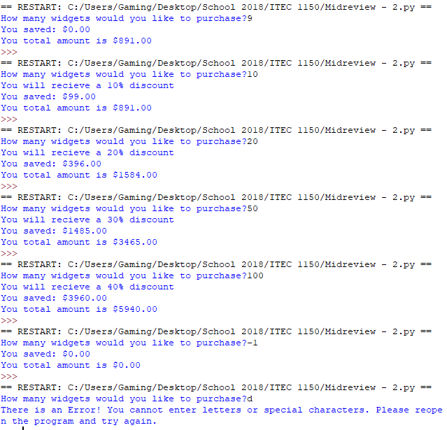

Midreview-3 Program:

# Author = Darren Isaacson

# This program is designed to create a personal budget list and accumulate the total

def main():

# Startup try function

try:

print("Welcome to the value calculator, This program will help you list your values and calculate them.\n-----------------------------------------------")

values = getValues() # Sendings input vales to collect list

count, list, total = listOutput(values) # Sends list to calculate the total of the list

printOutput(list,total) # Finishes the list output values

except: # General output values

print("Sorry there was an error. You cant enter and letters or special characters. Please reopen your program.")

def getValues():

# Adds blank list

valueList = []

go = "y"

num = 0

# Interates values and adds them to blank list

while go == 'y':

values = float(input("What is the pricing for value #%d" % (num + 1)))

while values <= 0:

values = float(input("Value must be greater than 0. What is the pricing for value #%d" % (num + 1)))

valueList.append(values)# Adds to the list

num += 1

go = input("Do you want to enter anothe value? Press y to enter another or another key to stop")

return valueList # Returns list to main

def listOutput(list):

total = 0 # Set base accumulator

for count in range(len(list)): # This loops function is to add each number in the list

total = total + list[count]

return count, list, total # Returns list and total back to main

def printOutput(list,total):

for x in list: # Prints each value in list

print("Value number in your list are %.2f" % x)

print("The total of your list is: $%.2f" % total) # Prints total

main()

